Revision History
Date | Version | Description | Author
23/11/2021 | 1.0 | Added Software Architecture Overview, COTS, SRS Mapping for all components, sequence diagram to Component 1 (Business Logic) | Gufran Yeşilyurt
23/11/2021 | 1.1 | Added class diagram to Component 1 (Business Logic) | Murat Can Altun
23/11/2021 | 1.2 | Added sequence and class diagrams to Component 2 (Presentation) | Alanur Bilgili  Kaan Yılmaz
23/11/2021 | 1.3 | Added sequence and class diagrams to Component 3 (Handling) | Damla Tütüncü  Görkem Öçmen
23/11/2021 | 1.4 | Added component interface diagram for Component 3 (Handling) | Gufran Yeşilyurt
29/11/2021 | 1.5 | Added aggregation arrows and cardinality to the class diagram in Component 1, clarified Revision History, removed SDP from Project References | Murat Can Altun
1/12/2021 | 1.6 | Fixed association and aggregation arrows, diagram style, attribute fields of the class diagram in Component 3 (3.3.2) | Damla Tütüncü
1/12/2021 | 1.7 | Made changes on the diagram at Section 2. Made modifications on diagrams 3.1.3 and 3.3.3 | Gufran Yeşilyurt  Görkem Öçmen
1/12/2021 | 1.8 | Made changes on the diagram at Section 3.2.3 | Kaan Yılmaz

TABLE OF CONTENTS
Revision History 1
1 Introduction 3
1.1 References 3
1.1.1 Project References 3
2 Software Architecture overview 3
3 Software design description 4
3.1 Component 1 4
3.1.1 Component interfaces 4
3.1.2 Component design description 4
3.1.3 Workflows and algorithms 5
3.1.4 Software requirements mapping 5
3.2 Component 2 5
3.2.1 Component interfaces 5
3.2.2 Component design description 6
3.2.3 Workflows and algorithms 6
3.2.4 Software requirements mapping 7
3.3 Component 3 7
3.3.1 Component interfaces 7
3.3.2 Component design description 8
3.3.3 Workflows and algorithms 8
3.3.4 Software requirements mapping 9
4 COTS Identification 9

Introduction

This document describes the design of the PAMA software system.

References

Project References

# | Document Identifier | Document Title
[SRS] | PAMA-SRS-01 | PAMA Software Requirements Specifications

Software Architecture overview
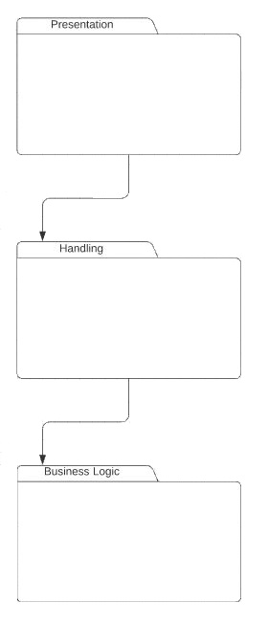
There are three main packages: Business Logic, Presentation and Handling. The Handling uses Business Logic, and Presentation uses Handling. When interacted with Presentation, Handling updates the Business Logic and Presentation according to the interaction.

Software design description

Component 1

Component interfaces
There are no interfaces used in the Business Logic Component.

Component design description
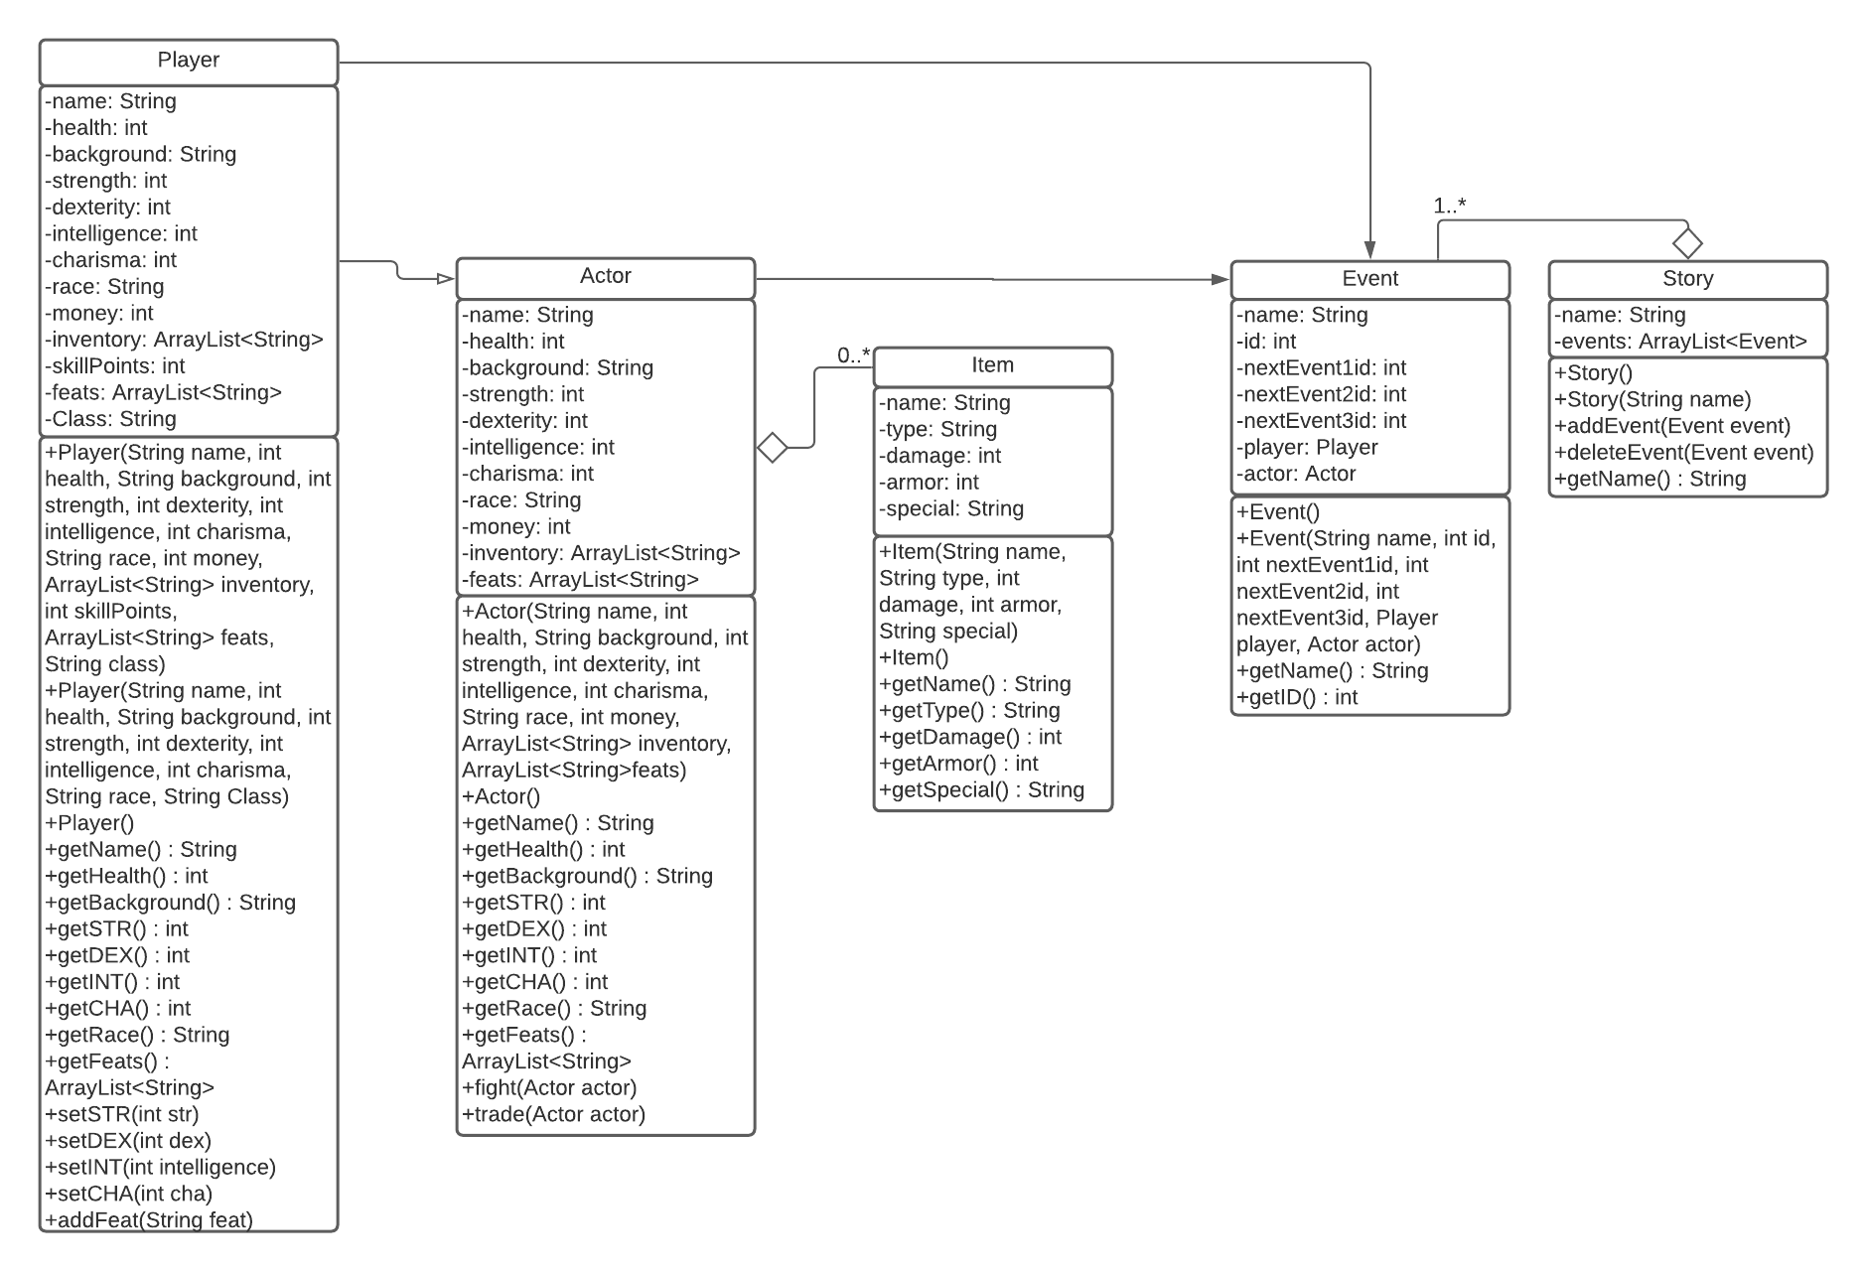

Workflows and algorithms
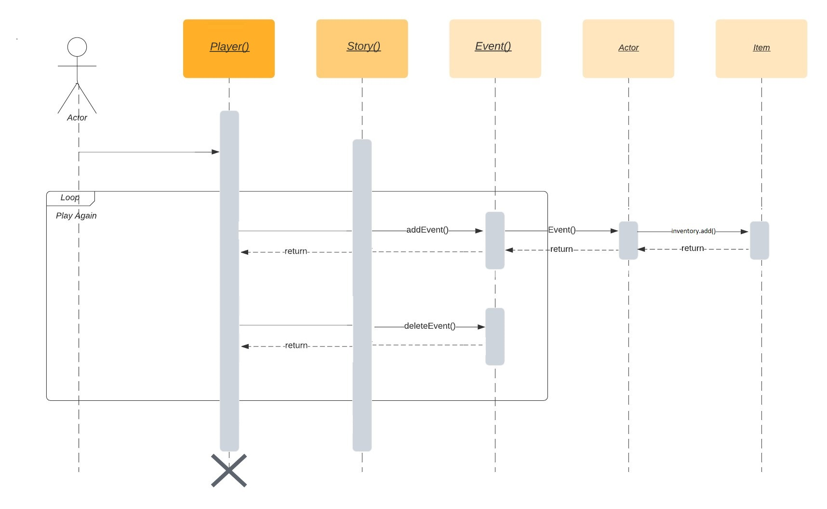

Software requirements mapping
SRS- PAMA-004
SRS- PAMA-007
SRS- PAMA-010
SRS- PAMA-011
SRS- PAMA-012

Component 2

Component interfaces
There are no interfaces used in the Presentation Component.

Component design description

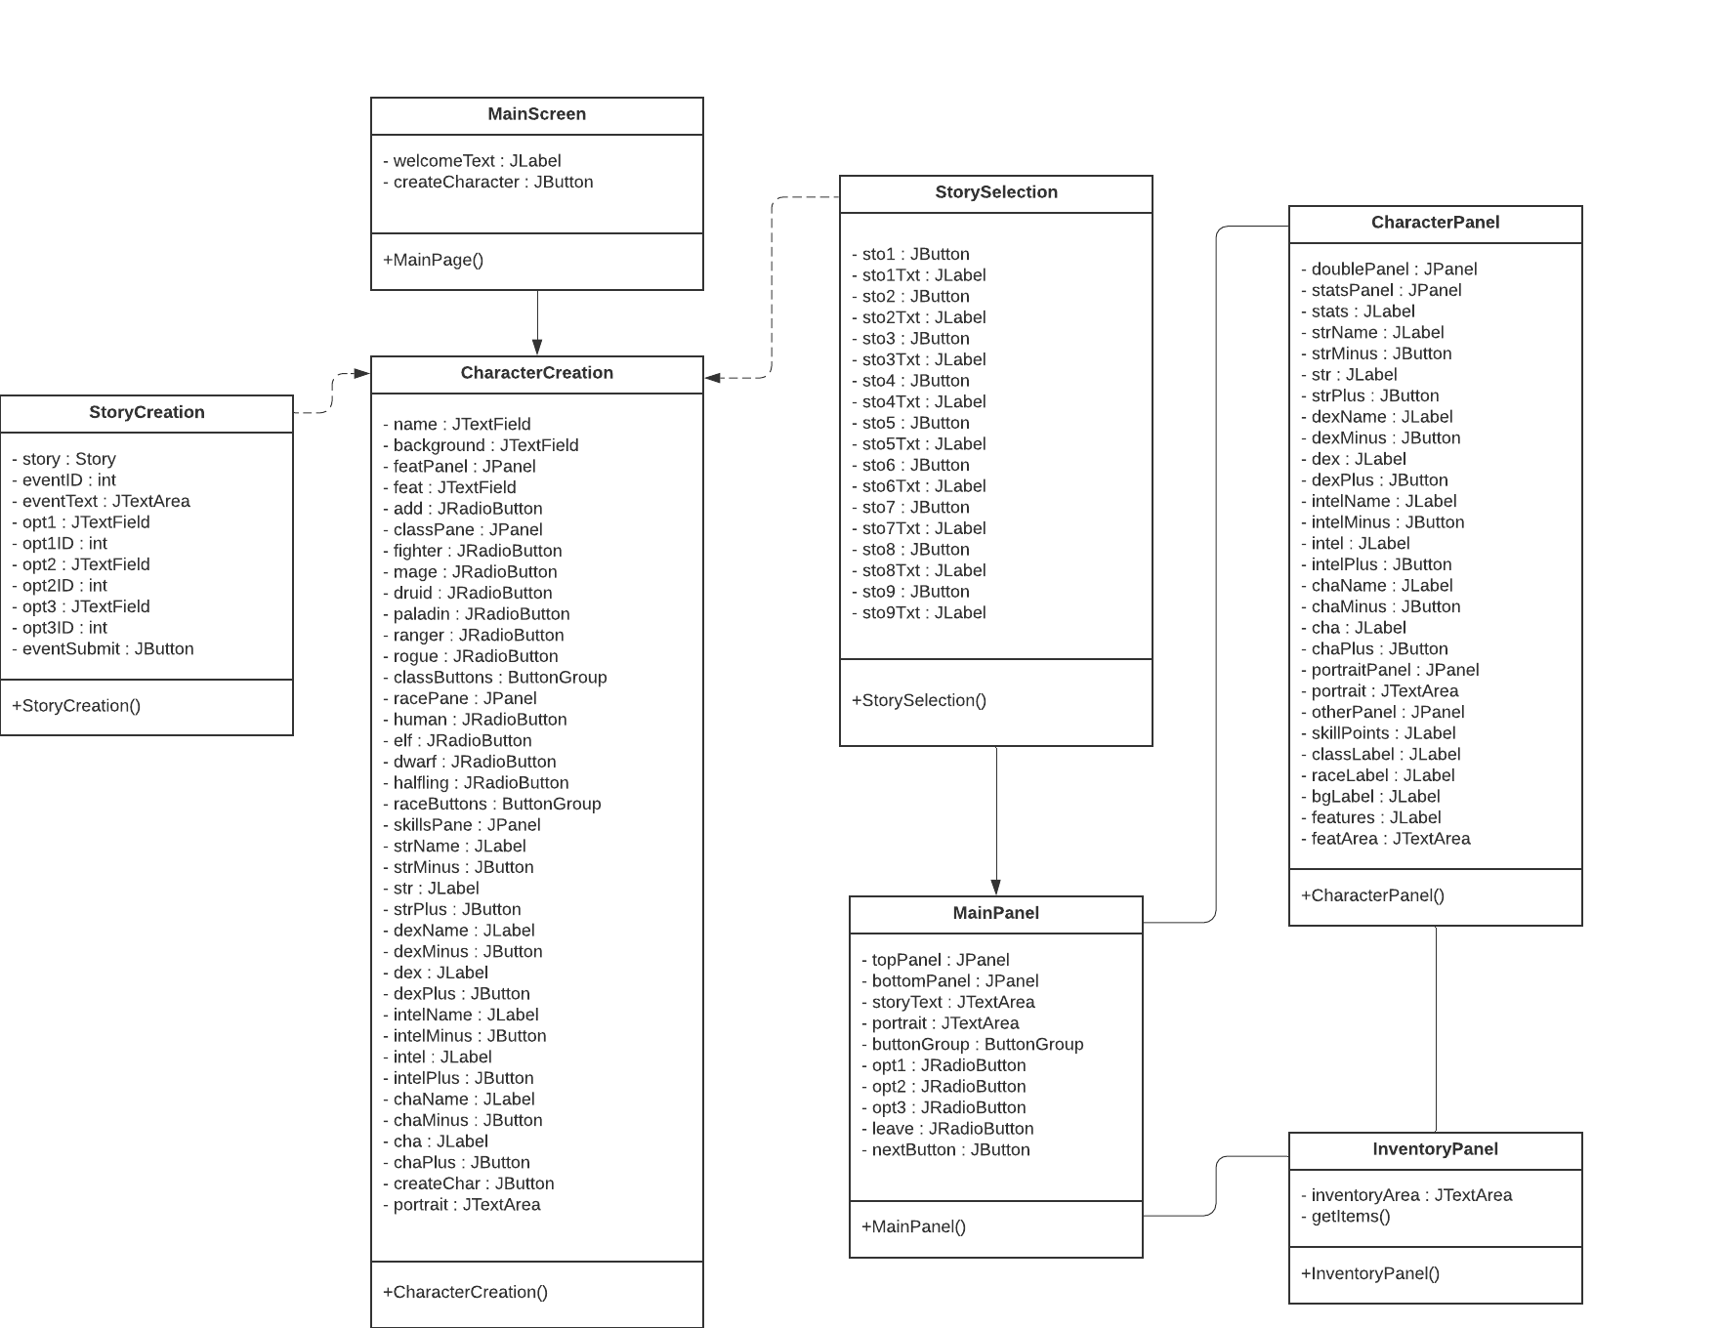

Workflows and algorithms
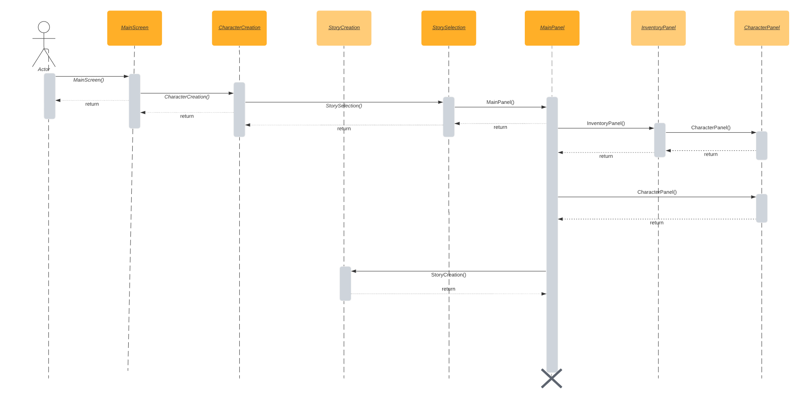

Software requirements mapping
SRS- PAMA-001
SRS- PAMA-002
SRS- PAMA-003
SRS- PAMA-005
SRS- PAMA-006
SRS- PAMA-008
SRS- PAMA-009
SRS- PAMA-0013

Component 3

Component interfaces

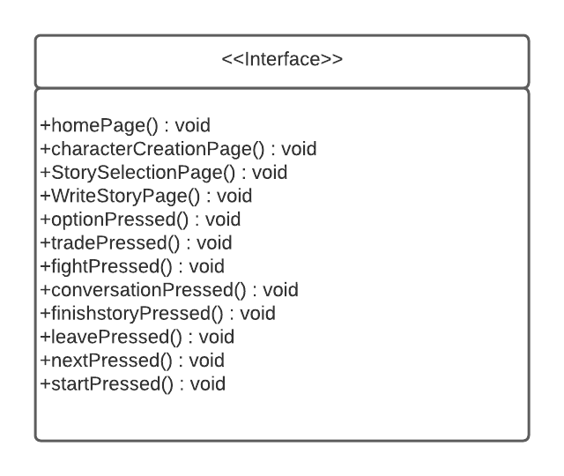

Component design description
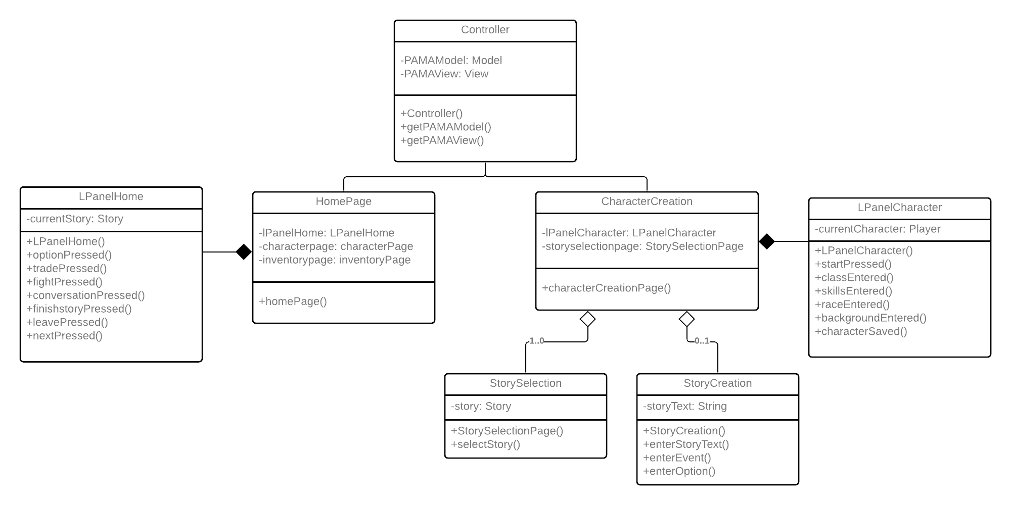

Workflows and algorithms
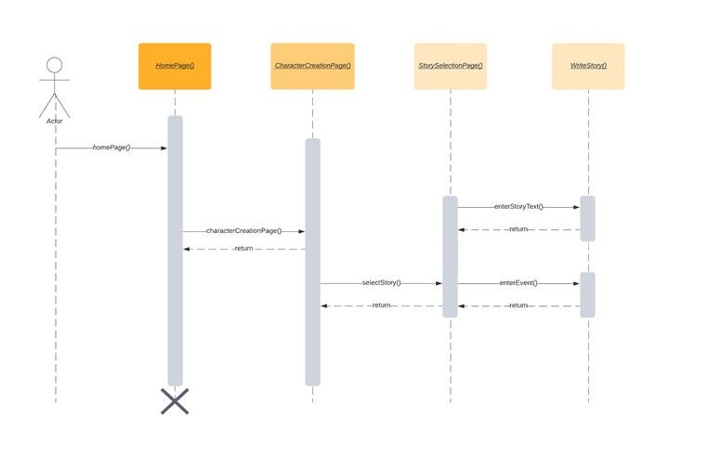

Software requirements mapping
SRS- PAMA-001
SRS- PAMA-005
SRS- PAMA-007
SRS- PAMA-008
SRS- PAMA-009
SRS- PAMA-011
SRS- PAMA-012

COTS Identification
None

